Lesson 3. Face Detection

Aim: How do we build a simple Facial Recognition App using API?

Objectives: After the lesson, students should be able to:
- Obtain basic understanding on facial recognition API

Do Now:
List the challenges in computational human facial recognition.

Class Discussion / Presentation:
- Define Face Detection:
  - find all faces in an image (if any) regardless of their position, scale, in plane rotation, pose, illumination, facial expressions, occlusions

- Importance of Face Detection:
- First step to every face recognition system

- Types of Face Detection:
- Face localization: find the exact location of a detected face
  - Detection of salient facial features such as eyes, nose, nostrils, eyebrows, mouth, etc

- Face tracking: detect (“follow”) a face in a video sequence

- Common Face Detection Techniques:
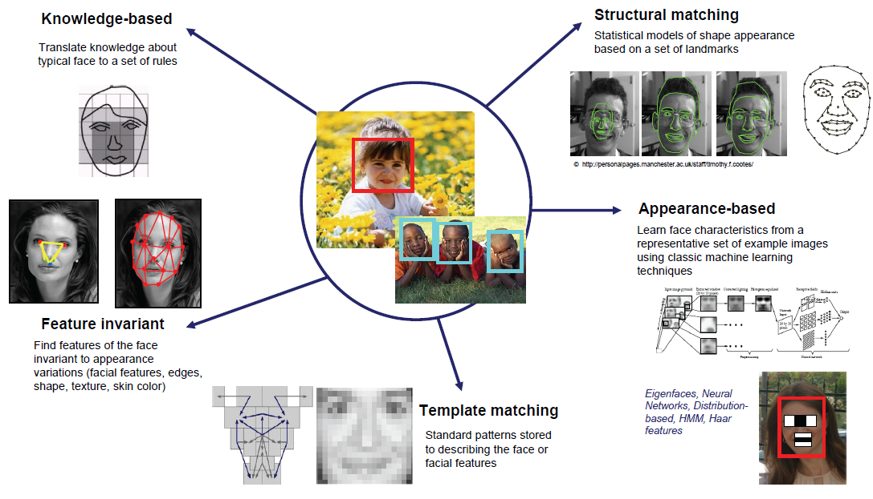

Pair – sharing Activity #1:

With the release of Google Play services 7.8, you can now use new Mobile Vision APIs which provide new Face Detection APIs that find human faces in image and video better and faster than before, and which offer smart services such as understanding faces at different orientations, detecting facial features, and understanding facial expressions.

Follow the instructions on https://codelabs.developers.google.com/codelabs/face-detection/index.html?index=..%2F..%2Findex#1, complete the simple face detection app.
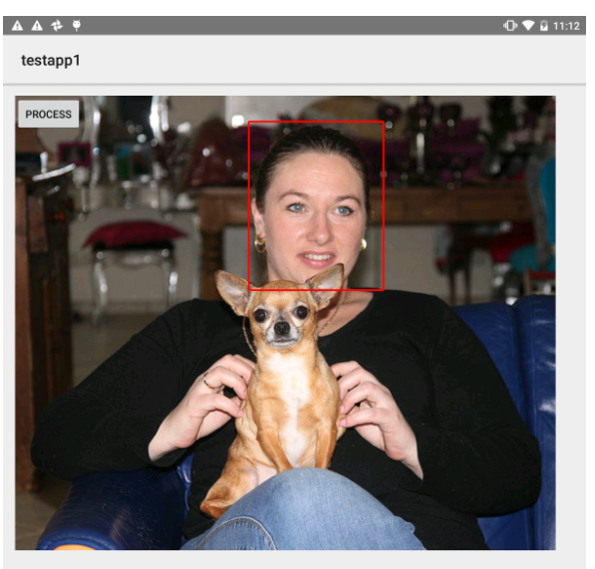

Pair – sharing Activity #2:
Our next project is the attendance app using facial recognition API. Research on how to output results from Android to Azure or Google doc.

